*Unit 02 VBA Homework – Melissa Mielke*

2016 Data Sample Screenshot:

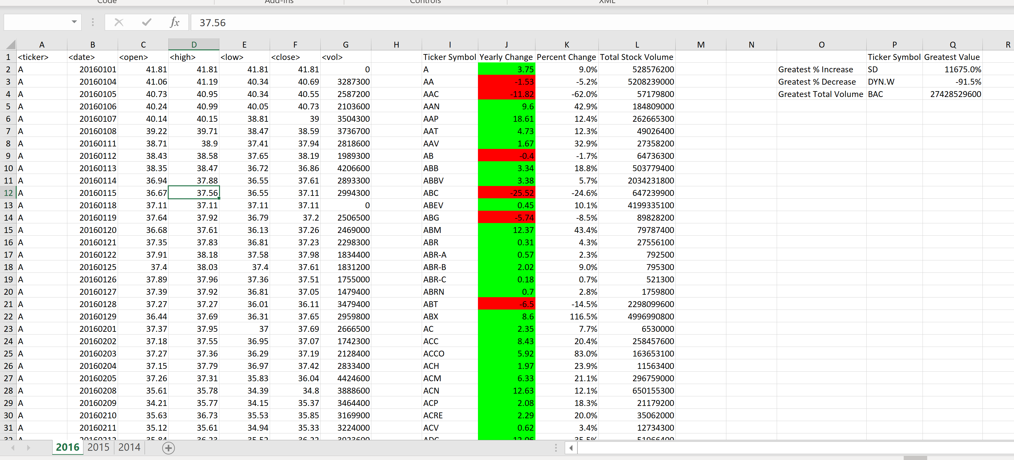

2015 Data Sample Screenshot:

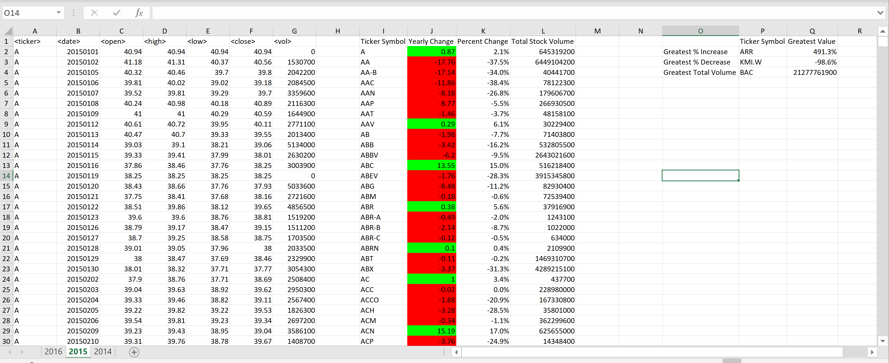

2014 Data Sample Screenshot:

